The purpose of this notebook is to serve as a guide for the
Newsletter Editor
and Email Coordinator

Please read the guidelines thoroughly and make note of any outdated statements for future edits.

DO NOT misplace this notebook.

Add your name to the bottom of the list on page 2, the “Previous Newsletter Editors” page.

Complete the end of year report page in October.

Turn this notebook in to the President no later than the October guild meeting.

Thank you for your participation in the guild!

Previous Newsletter Editors for Quilters Unlimited
2003 - 2004 | Jennifer Rozenzweig
2004 – 2005 | Jennifer Rozenqweig/Selena Foo
2005 – 2006 | Selena Foo
2006 – 2007 | Selena Foo
2007 – 2008 | Selena Foo
2008 – 2009 | Selena Foo
2009 – 2010 | Selena Foo
2010 – 2011 | Selena Foo
2011 – 2012 | Selena Foo
2012 – 2013 | Julie Love/Vickie Hooks
2013 – 2014 | Vickie Hooks
2014 – 2015 | Selena Foo
2016 | Karen Skinner
2017 | Karen Skinner
2018 | Tara Goodman
2019 | Tara Goodman
2020 | Carol Eskola
2021 | Carol Eskola
2022 | Carol Eskola

Guidelines

Per the Quilters Unlimited Policies and Procedures, V.A.10:
“The Newsletter Committee shall oversee the publication of the monthly newsletter, comprised of articles, calendar dates, notices, etc. as submitted by the membership. The chairperson/editor shall work with the Web coordinator to publish the newsletter on the website, and with the Membership Chairperson for any newsletter mailings.”

Additional information is found in Policies and Procedures, parts IX.D. and E. (The current version is included at the end of this document.)

Software

The newsletter is compiled using Microsoft Word. The Newsletter Editor will also save a copy of the final, approved newsletter in PDF format. PDF is the format used when the newsletter is posted to the Quilters Unlimited website.

“Newsletter” Email address

The email address for the Newsletter Editor is newsletter@quilttallahassee.com. The previous Editor will provide you with the password, and you will need to provide it to the next Editor. More information about the email system is contained later in this document.

Newsletter back-up team

The Newsletter Editor needs to arrange for a “back-up team” in case the Editor becomes ill or is injured. Team members need to have access to, and passwords for, the newsletter@quilttallahassee.com email address. They should be provided with a base/template file, and, on a periodic basis, any updates to the newsletter currently being drafted. Your back-ups may also be useful for proofreading and discussion of odd issues.

Year | Backup 1 | Backup 2

Deadlines for Articles

In each month’s newsletter, publish a deadline by which information must be submitted for publication in the next newsletter. Establish this deadline in view of your objective to distribute the newsletter as close as possible to the first of the month. Three days before the end of the month is generally sufficient time to create, approve and publish the newsletter by the first couple of days of the next month. Send an email to all Steering Committee members five days before the deadline to remind them to submit any materials that need to be published.

You may wish to contact the Website Coordinator to have an “Event” placed on the Calendar which shows the article-submittal deadline for the month. You can do this on a month-by-month basis or provide the entire year’s deadlines.

Articles/Notices

It is recommended that you make note at Guild meetings and Steering Committee meetings of information that should go in the newsletter but has not been submitted by other Chairpersons. They may have had events arise that kept them from providing this information, e.g., illness, family situations. Feel free to write articles yourself to cover these gaps but submit them in advance to the Guild President to make sure she is not doing the same thing.

You are free to develop whatever format you like for the design of the newsletter, but it is recommended that you create a design that requires minimal ink when printing. Using color fonts is fine, along with clipart or image files, but be somewhat parsimonious when doing so.

The current format, on a Word document base, frequently uses the table function to create boxes around the text/articles, with colored or invisible borders around them. The colored borders can be of varying width or style. Titles can be of varied fonts to add some variety, but the article text is typically the same simple font throughout.

Standard items in the newsletter usually include:
- List of officers and chairpersons
- An article from the guild President
- Information about the upcoming month’s program
- A list of the Sit-N-Stitch groups
- Newsletter article submittal deadline for the next month
- Requirements for receiving a printed newsletter
- A calendar of events
- Information on dealing with difficulty receiving electronic copies of the newsletter

The newsletter contains classified ads from guild members (only), only if one or more is submitted for the month. Submittal deadlines and related information need to be included regarding the ads.

Photographs

These are fine in the newsletter but can make the overall file size extremely large and for some ISPs too large to accept. Thus, you need to check the .jpg file size and resize it down to no more than 400 KB or so. (If you have a Windows operating system, “Paint” in the accessories section has resizing capability.)

Newsletter Preview and Approval

Prior to formal publication in print form and on the website, the newsletter should be reviewed by the guild President (or President-Elect if the President is unavailable). This is in order to (1) double-check whether all needed articles are included (she may know of topics under review that you do not); and (2) have someone proofread the articles.

Posting the Newsletter to the Website

When you have been cleared to have the newsletter sent to the membership, send the document in PDF format via email to the website administrator (John Babich) at jbthree.productions@gmail.com. In your email, direct the website administrator to post the newsletter to the Quilters Unlimited website; this includes establishing a link from the Bulletin Board on our home page and updating the month in that text, as well as updating the information and link at quilttallahassee.com/about-quilters-unlimited/newsletters/.

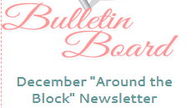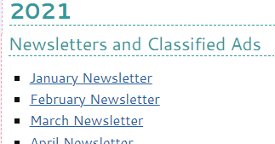

In that email, remind the administrator to send you the newsletter’s URL so that you can include that link in the email blast to the membership. Information about creating/sending email blasts with the newsletter or with other information is presented later in this document.

When the website administrator notifies you that the newsletter has been posted, go to the QU website, and check the links and the text in both of those places to make sure that the text is accurate and that the links launch the appropriate newsletter. Notify the web administrator of any errors so that corrections may be made before distributing the email blast/newsletter.

Newsletter Paper Printing

Those members without email access and who wish to have a paper copy mailed to them must submit SASEs (self-addressed stamped envelopes) in advance. You will be the keeper of the envelopes and need to remind those using the SASE mode if their submitted SASEs are running low. These must be printed in black and white.

Newsletter Mail-outs

It is up to you whether to have a copying company/store like Kinko’s or Office Depot do the printing, or to use your home printer.

Home Printing
If you only print three or so copies, it may be more convenient to print them at home, staple them, and then stuff the envelopes. Submit a reimbursement request form to the guild treasurer, listing the number of pages printed (e.g., for an 8-page issue with three copies, that is 24 pages). The rate to charge is usually based on the rate Office Depot or similar store would charge for printing and stapling.

Rather than submitting a reimbursement request every month, it may be more convenient to submit one every few months.

Store Printing
You will need to email the file or do a web upload of the file to the company of your choice. Request that these be double-sided printing, collated, and stapled. They will request payment, and you will need to use your personal credit card or cash for that. Keep track of your receipts/records so that you can use them as part of the required documentation for the guild request form. You will need to physically go to the store and pick up the completed copies.

Reimbursement Guidelines

Use the current QU “Check Reimbursement Form”, located on the website at quilttallahassee.com/membership/forms. You should print a master from which to make copies as needed. Attach originals of receipts, using additional blank paper if needed. Tape the receipts to the form and circle the total for reimbursement.

Normally the Treasurer will be at the guild meetings and will have the guild’s checkbook with her. If so, turn in the completed form with receipts to the Treasurer at the meeting. She should provide you with a check for the total reimbursement before the end of the meeting.

If the Treasurer is not present at the meeting, or you have elected to send in the request by mail, you may want to call the Treasurer if you need reimbursement to be expedited.

It is helpful to keep an expenditure log of supplies purchased and/or services provided. This will assist when determining future budgets. It will also help future chairpersons to see where, when and the quantities to purchase.

Newsletter Email Blasts

Once the tasks under “Posting the Newsletter to the Website” have been completed, you must send an email message to the entire membership. The software used for this purpose is “Mail Chimp”.

Log in to Mail Chimp at https://login.mailchimp.com/ using your personal email address (not your “newsletter” address). If you are new to this system, the Web Coordinator or the Web Administrator can give you initial access to the system. Logging in launches the system’s home page, where you will see a list of all recent emails.

For distribution of the newsletter, it is simplest to replicate a prior email than to create a new one. At the screen listing all of our “campaigns” (emails), hover the curser over the most recent QU newsletter email. A “+” icon and the command “replicate campaign” will appear.
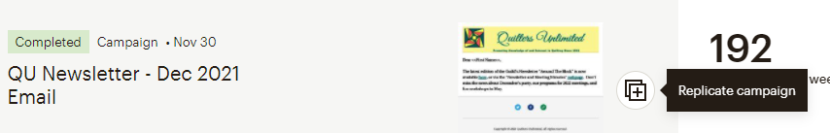

Left click on the “+” icon. The edit screen shown next will appear.

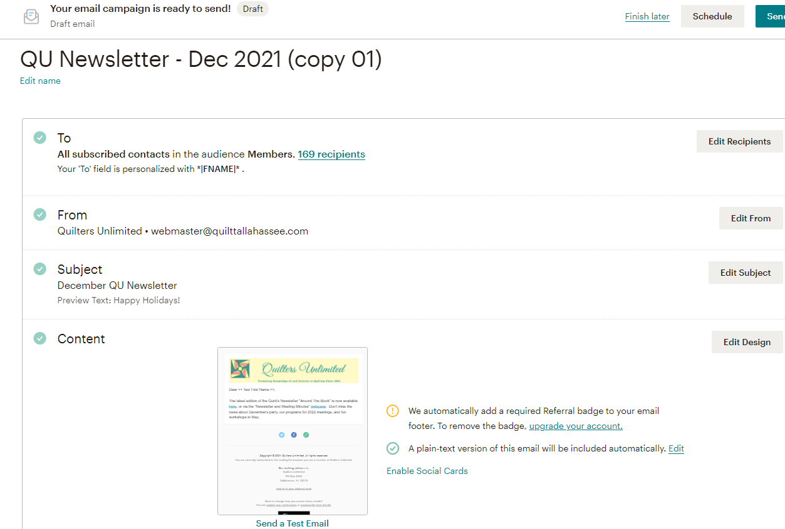

This is the copy of the earlier email, ready to be edited. Edit the campaign name; do not edit “To” or “From”. Edit the subject, along with the preview text if any. Finally, edit the content; begin by clicking the “Edit Design” button.
On the screen that is now launched, hover the cursor over the text block to make the edit icons for that section appear. (Do not edit the “Quilters Unlimited” header.) Left click on the pencil (edit) icon.

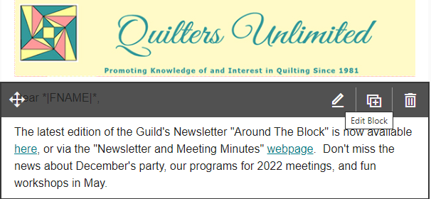

The right side of the screen displays the same text; edit the text there as necessary. (Right side of screen is shown in the next screen shot.)
IMPORTANT: Now double left click on the link “here” and the pop-up box shown below will appear.
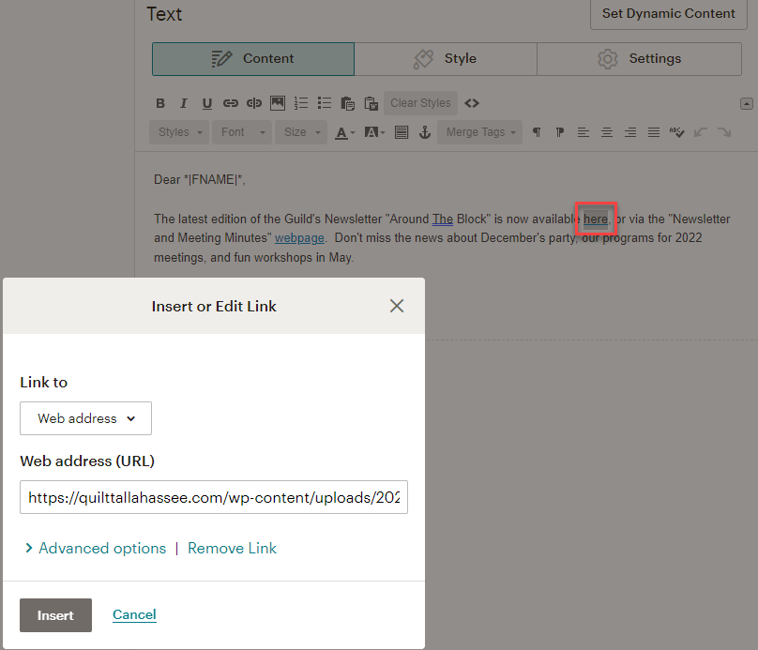

Overwrite the URL displayed in the “Insert or Edit Link” box with the new URL for this month’s newsletter, as provided to you by the Web Administrator in their email.
Do NOT make any changes to the second link in this text (“webpage”) as that link is to a page, not to a specific document, and the page does not change.
Click the “Continue” button in the upper right corner of the edit page (the one you are already on) to return to the prior screen. In the “Content” section, hover the cursor over the small icon of the completed email; that icon will now be overlayed with “Preview”.
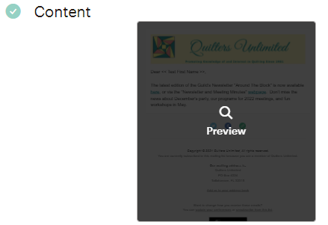

Single left click on “Preview” to view the revised email. If there are errors, make sure you correct them now before you send the email.
Test BOTH links in the Preview email. If they don’t launch the expected newsletter or web page, work with the Web Administrator or Web Coordinator to identify and correct the problem.
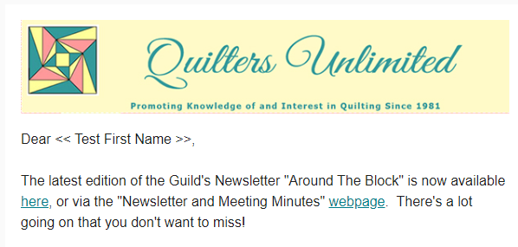

When you are satisfied that the email and links are correct, click the large “X” in the upper right corner of this page (not the x which closes your internet browser).
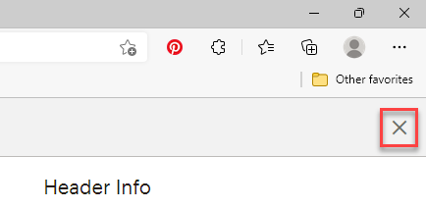

This will return you to the main edit page where you may elect to save the email to finish it later, schedule it to be sent on a specific date, or send it immediately. Only in exceptional circumstances will you select anything other than “Send”.

Once you’ve sent the email, it and the newsletter will be available to everyone in the Mail Chimp distribution list (the “audience”).

Other Email Blasts

All requests for email blasts must be submitted either through the President or the Email Coordinator. These may contain information about changes to meeting dates, events of interest to the membership, etc.

It is simpler to replicate a prior email than to create a new one. The process for doing this is exactly the same as covered in the preceding section for replicating an email for the newsletter. However, if you want to get creative and produce an email from “scratch”, the following instructions apply.

Log in to Mail Chimp at https://login.mailchimp.com/ using your personal email address (not your “newsletter” address). If you are new to this system, the Web Coordinator or the Web Administrator can give you initial access to the system. On the Home page, click on the “campaigns” icon (megaphone).
This will take you to the “Campaigns” screen. Next, in the upper right-hand corner of this screen, click the “Create Campaign” button. On the next screen, click on “Email” in the left-hand panel. Three options now appear under “Email”. Click on “Regular”

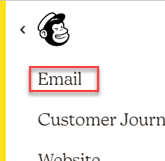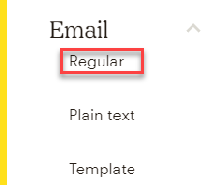

Megaphone Email Options

On the next screen you are prompted to give the email a name. Enter this as the “campaign name”. This is just a short tag to identify the email, such as “Meeting Location Change”, and it only appears in Mail Chimp, not the email itself. Pressing Enter takes you to the edit screen for composing your email. You can edit the campaign name on this screen as the first step if necessary.

Add Recipients: Clicking this button allows you to select to whom the email will be sent. The only possible choices are “Single Tests”, which will only send the email to two people identified in the system for testing purposes, or “Membership”. Always select Membership, which will send the email to all addresses in the Mail Chimp database of QU members. It is not possible to specify a subset of the membership or a list of addresses other than the full membership. If you need to email a select group, that should be done either using your personal email or your “newsletter email”. After selecting “Membership” confirm that the field “segment or tag” displays “all subscribers in audience.”

To: To personalize the “To” field with the member’s first name, in the “Merge Tag” field select *|FNAME|*. Press “Save” to return to the main edit screen. At this and other points in the process, you may elect to press “Finish Later” at the top of the page. This will save the campaign as a draft and you may return to finish it later.

From: Mail Chimp automatically places our default values in these two fields; do not edit them.

Add Subject: Add your text for the email’s subject line. This should be short, e.g. “January Guild Meeting Location Change”. Then add your preview text if desired; this is optional.

Design Email: The next screen is “Select a Template”. It is recommended that you use the “Basic” template, which is currently used for all email blasts. Once you have selected the template, the screen will display the edit mode for your email. The header showing our logo and name are already populated; do not edit. Edit the text as necessary. Do NOT edit any of the information below the body of the email; this auto-populates with what is needed. When finished, click the “Continue” button. This returns you to the main edit page. It is recommended that at this point you “Preview” your email before sending it, following the directions previously covered for newsletter email blasts.

When completed, press “Send”, and your email will be distributed to the membership.

Maintain Mail Chimp Email Data

The names and email addresses of QU’s membership are maintained in Mail Chimp. However, members who do not renew membership are not removed from the database. This may change in future.

The Membership Vice President will notify you when new members join QU and will provide the information you need to set them up in Mail Chimp for email blasts. She will also notify you of name/email address changes as they are brought to her attention.

To view and/or maintain the data, from the home page in Mail Chimp, click on the “audiences” icon in the left-hand panel.

This launches the Audiences page. On this page, you will select which audience group you want to view. We are limited to only two audiences, which are “members” and “test group”. The screen will default to the members audience. (If you plan to run a “test”, view the test group to see who is in it and whether they are still members. Notify them before sending them a test email from Mail Chimp.)

Click on “View Contacts” and a list of all records in the members audience is displayed. You may sort the list by clicking on various column headers.

The “Email Marketing” column shows “subscribed”, “cleaned”, or “unsubscribed”. Email will only be sent to those that are subscribed. If an address shows as “unsubscribed”, that person elected to be dropped from the mailing list and may not be re-added. If it shows as “cleaned”, an email sent to that address failed to process, as the email address is invalid. Review these periodically to make any necessary corrections. You may want to Archive “cleaned” records. To archive, click on the checkbox to the left of the data record in the list that you want to archive, then select “Archive” from the drop-down lists of “Actions”. The record will disappear from your list.

To edit an existing record, left click on the email address. Various information about this person is displayed, including whether email campaigns have been sent to them and whether they opened the email. To edit the name and/or email address, click on the pertinent “edit” button on the right side of the page. Make your changes in the pop-up box that appears and save.

To add a new record, make sure that “Current audience” is selected, then click on “Manage Audience”. From the drop-down list that appears, select “Add a Subscriber”.

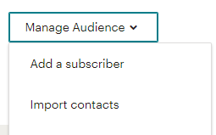

On the edit screen that now appears, enter the new data record’s email address, first name, and last name. Ignore “Not President – Annual Gift” (obsolete tag). Select “email type” as HTML, ignore “Tags”, check the box for “This person gave me permission to email them”, and if you know/think that a data record for this address already exists, check the last box as well (“If this person is already in my audience, update their profile.”).

You may also import records via a spreadsheet (“Import contacts” under “Manage Audience”). This is almost never done but would be a great help if it is decided to completely refresh the database from our Membership records.

Webmail Information and Path to Tutorial

You should frequently check your “newsletter” QU email address. The system we use is Webmail, and the URL is webmail@quilttallahassee.com. It is recommended that you set up your newsletter email to have copies forwarded automatically to your personal email account, which lessens the need to check both your personal and your newsletter email. Do this in the system settings for Webmail, tab “Forwarding”.

The President, Treasurer, and Membership VP each have a Webmail address. They may contact you occasionally (especially when officers change) with questions about how to use this system. You should help them as far as possible, but you may also contact our Web Administrator (John Babich at jbthree.productions@gmail.com) if further assistance is needed.

There is a tutorial for this system on QU’s website, at Microsoft Word - Quilters Unlimited E-Mail Directions-v2.doc (quilttallahassee.com) which you may find to be of additional help. This is the link to the Email Coordinator’s QU “Notebook”; this tutorial is all that is in that notebook.

Contacts: The database of contacts in this system is from an old dump of data from membership records. While it is virtually the same for all Quilt Tallahassee email addresses, as with any email system, if one user updates “contacts” it does not affect the other users. Generally, all the email addresses you may require are in your contacts, but if not you will need to add them manually as needed. It is recommended that you create a contact “group” for the members of the Steering Committee each year, as this is particularly helpful when you send your monthly reminders to the Steering Committee that the newsletter deadline is approaching.

Review Website Information

On a regular basis (at least every six months), review the information on QU website page http://quilttallahassee.com/about-quilters-unlimited/newsletters/. This is to assure that there are no errors, and no duplications. If information has changed or is out-of-date, provide the updates to the website coordinator.

Budget

Refer to the approved budget for the allocation for the budget for newsletter expenses. If you are unsure of what the amount is, ask the Treasurer. Be prepared to make a recommendation to the Treasurer to modify the budget as needed. Remember, budget amounts are estimates. Keep all receipts and accurate records of money spent and refer to the Reimbursement Guidelines in this document for instructions.

End-of-Year Report

Your end-of-year report is due in October. Access the current version of the form for this report at quilttallahassee.com/membership/forms, under the caption “End-of-Year Officer/Chair Reports”. Print and complete the form and provide it to the guild President.

Other Information

The guild is a tax-exempt organization under the provisions of 501(c)(4). Our designation as a non-profit organization affects our handling of funds and other matters.

Frequently Asked Questions

- Do I have to attend every guild meeting to be the Newsletter Editor?
No, you do not, but it is definitely recommended.
- Do I have to attend the steering committee meetings?
All chairpersons and officers comprise the steering committee and you should therefore plan to attend as many as possible. The President may occasionally call a mandatory meeting for all steering committee members. In this situation, input and votes are needed from as many chairpersons as possible and your opinions would be greatly valued.

Excerpt – Policies and Procedures, December 2021

IX. INDIVIDUAL STANDING COMMITTEE POLICIES

D. Internet Committee
This Committee is comprised of three co-chairpersons, one of whom shall attend the Steering Committee meetings on behalf of this committee. These Chairpersons are:
1. The Website Coordinator. The Website Coordinator shall coordinate with the paid Web Administrator and provides editorial oversight of the guild’s WordPress account.
2. The Social Media Coordinator(s). The Social Media Coordinator(s) shall make posts to Facebook. No posts to sell items will be permitted on the guild Facebook page.
3. The Email Coordinator. The Email Coordinator shall work with the Membership Vice President to keep the MailChimp “email blast system” updated with the addresses of new members and changes to addresses for existing members. All requests for “E-mail Blasts” shall be submitted through the President or through the Email Coordinator. The Email Coordinator will also assist QU users of the @quilttallahassee.com email accounts as needed. These duties have been folded into the functions handled by the Newsletter Editor.

E. Newsletter
1. Administration
a) The Newsletter Chairperson is responsible for printing and mailing any hard copy newsletter mailings. The Newsletter Chairperson also ensures that the newsletter is posted to the website by the guild Web Coordinator or by the paid guild Webmaster (Web Administrator).
b) Members desiring a mailed newsletter must provide a letter-size stamped self-addressed envelope to the Newsletter Chairperson at least 30 days in advance of the publication date. Mailings shall only be made to paying members, whose status is verified by the Membership Vice President.
c) A limited number of black and white copies of the newsletter shall be available for guests and new members at each meeting. This is handled by the Membership Vice President.
2. Newsletter printing modes and reimbursement billing
a) The version of the newsletter published on the guild website shall, to the extent possible, use color mode for images such as Block-of-the-Month and workshops, and may be black/white for the remainder.
b) The version of the newsletter for mailing to members and for handouts to guests or new members at the meeting shall be printed in black and white. When possible, the newsletter shall be printed in double-sided mode.
c) The Newsletter Editor shall, when submitting a reimbursement request for printing costs, include:
i. A log identifying, on a per-month basis, how many pages were printed, whether these were printed double-sided, and sheets stapled/collated.
ii. An identification of the basis of the reimbursement billing, i.e.,
• printing/collating/stapling at a commercial printer and payment to that entity,
• printing on a personal printer detailing cost per sheet of paper plus cost per of ink per piece of paper plus labor for collating and stapling
• printing on a personal printer but using a commercial entity’s website cost calculator for the specific job.
d) The Newsletter Editor is authorized to request reimbursement on a monthly basis, or other timeframe, but shall submit at least one for the current year no later than five days after the December guild meeting of each year, in order to facilitate the closing of the yearly books by the Treasurer.
3. Classified Ads
a) Ads are published solely as a courtesy to members and may or may not be published in each issue of the newsletter, even if timely requested.
b) The Newsletter Editor shall have sole authority setting requirements for Ads, including but not limited to submittal deadlines, and limitations on number, file type, and size of any accompanying photographs.
c) A new request is required to be submitted each month for publication about an item advertised in a previous month’s newsletter.
d) Ads shall only be published for members. If a member desires to have a “public benefit” item posted “on behalf” of another person, the member must be the listed contact person.

