Quilters Unlimited

Guide

For

Opportunity Quilt Committee A
(even years)

Chairperson

Quilters Unlimited

Guide

For

Opportunity Quilt Committee B
(odd years)

Chairperson

The purpose of this notebook is to serve as a guide for the

Opportunity Quilt Committee Chairperson

Although the role may seem obvious in some ways, documentation of the responsibilities will ensure consistency from year to year and promote a smooth flow of events during the meetings.

Please read the guidelines thoroughly and make note of any outdated statements for future edits.

DO NOT misplace this notebook.

Add your name to the bottom of the list on the “Previous Chairpersons” page.

Complete the comments/helpful hints page at the end of your tenure.

Turn your report in to the President no later than the October guild meeting.

Thank you for your participation in the Guild!

Previous Chairpersons
For
Opportunity Quilt Committee

2006 | Ardell McGavin
2007 | Meredith Smith
2008 | Esther Weiner
2009 | Jessica Duke
2010 | Topi Henderson
2011 | Linda Dozier
2012 | Linda O’Sullivan | Marilyn Kelley
2013 | Marilyn Kelley
2014 | Marilyn Kelley
2015 | Betty Rinkel
2016 | Geni Raines
2017 | Karen Kunz
2018 | Marsha Walper
2019
2020
2021
2022
2023
2024
2025
2026
2027
Detailed Opportunity Quilt Timeline

Make a working copy of this timeline to write on.
Make adjustments to dates if show opens earlier in year than August.

Two years before Annual Capital City Quilt Show opens in August

October
- guild officers voted in and new committee chairpersons selected
- meet with previous committee chairperson to go over notebook and suggestions

November
- decide on quilt design related to theme and fabric to be purchased or donated
- write newsletter announcement requesting donated fabric
- former and new Opportunity Quilt Chairpersons attend Steering Committee
Note: in newsletter ask for specific fabric to be brought to December QU meeting

December
- design kits for individual blocks or sections of quilt
- collect donated fabric at December guild meeting
Note: buy needed fabric for quilt top

One year before Annual Capital City Quilt Show opens in August

January
- make kits for blocks
Note: number kits and prepare kit sign-out sheet for QU meeting

February
- hand out kits at QU meeting
Note: 1. members sign by number of their kit
2. sign-up sheet for hand quilters (if needed)

March & April
- kits returned
- begin construction of quilt top
Note: keep track of kits and prompt for those not yet returned

May & June
- complete construction of quilt top
- make decision about machine/hand quilting
Note: seek out long-arm quilter and negotiate fee

July & August
- prepare quilt sandwich with batting and backing
- long-arm quilting completed
- add hand quilting, if needed
Note: check with long-arm quilter about specifics of quilt sandwich

September & October
- hand quilting completed
- sew on quilt binding, sleeve, and label

November & December
- create marketing plan for ticket sales
- order tickets from Dura Quick Print, N. Monroe St.
- take photos of quilt for marketing and newsletter
Note: include dates and venues for selling tickets in marketing plan
Question?? Create contest for person who sells most tickets?? Prize=dues year

Year of Annual Capital City Quilt Show opening in August

January
- contact Museum of Florida History about photographing quilt
- display quilt at area quilt shops and retreats to promote show and sell tickets

February
- take quilt to Museum to be photographed

March
- fill out form for quilt show entry (title, size, information about quilt)
Note: March quilt show at Trenton will give us free table to sell tickets for quilt

April, May, June, July, August (until show opens)
- sell sets of tickets, 6/$10, before each QU meeting from 6:30-7:00 pm
- drawing for 6 free tickets from names of those buying sets of tickets
- sign-up sheet for members to take tickets to sell (number of tickets)
- ticket income is an important part of budget, but not a requirement of membership
Note: 1. bring quilt to QU meetings to promote ticket sales
2. record name, number of tickets taken, money and tickets returned for those who take tickets to sell

Policy and Procedures on QU Web Site

Opportunity Quilt General Timeline
Make adjustments to dates if show opens earlier in year than August.

Two years before Annual Capital City Quilt Show opens in August
October - guild officers voted in and new committee chairpersons selected
- meet with previous committee chairperson to go over notebook
November - decide on quilt design related to theme and fabric needed
- write newsletter announcement requesting donated fabric
- former and new chairpersons attend Steering Committee
December - design kits for individual blocks or sections of quilt
- collect donated fabric at December guild meeting

One year before Annual Capital City Quilt Show opens in August
January - make kits for blocks
February - hand out kits at QU meeting
March & April - kits returned
- begin construction of quilt top
May & June - complete construction of quilt top
- make decision about machine/hand quilting
July & August - prepare quilt sandwich with batting and backing
- long-arm quilting completed; add hand quilting, if needed
September & October - hand quilting completed
- sew on quilt binding, sleeve, and label
November & December - create marketing plan for ticket sales
- order tickets from Dura Quick Print, N. Monroe St.
- take photos of quilt for marketing and newsletter

Year of Annual Capital City Quilt Show opening in August
January - contact Museum of Florida History about photographing quilt
- display quilt at quilt shops and retreats to sell tickets
February - take quilt to Museum to be photographed
March - fill out form for quilt show entry
April, May, June, July, August (until show opens)
- sell sets of tickets, 6/$10, before each QU meeting from 6:30-7:00 pm
- drawing for 6 free tickets from names of those buying sets of tickets
- sign-up sheet for members to take tickets to sell
- ticket income is an important part of budget, but not a requirement of
membership

Budget:
The budget for the year will be approved by the Steering Committee with the Opportunity Quilt Chairperson’s input.

Deposits
Make deposits of all money collected from ticket sales in a timely manner. Ask the Treasurer for bank information. Send an email to the Treasurer with a copy of the deposit slip, the committee name, date of deposit, and amount deposited.

Reimbursements
Keep all your receipts. Use the form in this notebook or the form on Quilters Unlimited web site for reimbursement.

Guild Property:
You will have in your possession the guild notebook for Opportunity Quilt Committee Chairperson

Tallahassee Quilters Unlimited - Quilt Show and Challenge Themes

1989 A Trip through Time
1990 Patches of Sunshine, Pattern of Life (Everything Olde is New Again – Challenge theme)
1991 Nine-Patch for the Nineties
1992 A Colorful Land of Counterpane (Freedom of Choice – Challenge theme)
1993 Memories Are Made of This
1994 When You Wish Upon A Star
1995 Threads Through Time (Green – Challenge theme)
1996 All Things Bright & Beautiful
1997 Everything’s Lovely in My Garden
1998 Sing the Blues or Singin’ the Blues
1999 When Life Gives You Scraps, Make a Quilt
2000 Beyond the Block - A Creative Leap
2001 An Odyssey in 3−D
2002 From Dresden Plate to Broken Dishes
2003 Canopy Roads (featuring Contemporary & Traditional Quilts)
2004: Fire & Ice (featuring contrasting kinds of quilts)
2005 Southern Exposure
2006 What Goes Around Comes Around - 25thAnniversary Capital City Quilt Show
2007 Our Lives in Fabric
2008 Through the Looking Glass
2009 From Canvas to Quilt
2010 The Garden Party
2011 Diamonds are a Girl’s Best Friend - 30thAnniversary Capital City Quilt Show
2012 Tomorrow's Quilts Today
2013 Road to Florida
2014 Starry, Starry Night
omit - 2015 For Every Quilt There is a Season – No Show, Museum closed
2016 By the Water’s Edge
2017 Sentimental Journey
2018 Out of the Blue
2019 Autumn Reverie
2020 Jazz It Up
2021 Come Fly With Me
2022 A Ruby Celebration - 40 Years of Quilting (moved to 2022, 40th year of show)
2023 Metamorphosis (Transformations)
2024 Floral Fantasy
2025 A Walk in the Woods
2026 Kaleidoscope of Color

Challenges started in 1987 – no themes mentioned, just rules

Opportunity Quilt Guidelines

The role of the Opportunity Quilt chairperson is to design and coordinate the execution of the guild’s annual opportunity quilt. The opportunity quilt is similar to a raffle quilt in that members and the public have the opportunity to win it when purchasing a ticket. Also, all guild members have the opportunity to participate in making the quilt. The quilt is displayed throughout the duration of the Annual Capital City Quilt Show at the Museum of Florida History and the winning name is drawn at the close of the show.

Check with the timeline in this notebook to create a schedule for working on the quilt.

Quilt Design:
The design of the quilt is based on the Annual Capital City Quilt Show theme.

The opportunity quilt is an important fund raiser for the guild and will be made by many guild members. In addition to following the annual show theme, your design goals should include:
- A design and colors that would be pleasing to many individuals
- Block assembly that can be offered as kits
- Hand quilting or other handwork that will add to the value and allow member involvement.
- Minimum size to fit a queen bed, which is 60” x 80”. A quilt with a 10” drape on three sides will measure 80” wide by 90” long.

After creating a design, solicit fabric donations from guild members in specified colors. You can request donations of fat quarters or yardage. This will assist in keeping the production cost down and also contributes to more members being involved in the creation of the quilt.

Block Kits:
When creating the block kits, allow yourself extra fabric and count on not receiving every completed block by your deadline. You may need to construct a few blocks yourself to replace some that are returned, but not made according the specified instructions and therefore determined unusable. This is an unfortunate characteristic of many hands being involved, but should not distract from the purpose of guild-wide involvement. Planning ahead will save you time in the long run.

Wash, dry, and iron all fabrics prior to cutting to prevent future shrinkage and color bleeding. Requesting that members do this prior to donating the fabric is not a guarantee that it will be done.

Package the block kits in Ziploc bags with detailed instructions for the assembly. Include a photo or sketch of the completed block with the directions so they have a visual image of how it should look. Specify the seam allowance, when and how to press the seams, and what final measurements should be. Specify absolutely no trimming to allow a margin to work with when you and your committee sew the blocks together.

Include your name and contact information if there are questions. Note that it is okay to not complete the block if the guild member is unsure of the instructions.

Put the deadline for returning the completed kit to you in bold print.

Block kits do not need to be a complete block. If your quilt design involves some fairly complicated piecing, you can create kits that only involve sewing a portion of the block together.

When you disseminate the quilt block kits, sign them out as numbered kits and obtain names and phone numbers of each person who takes a kit. Post reminders in the newsletter about the deadline to return the completed kits to you.

Quilt Construction:
Trim the blocks and put the quilt top together with your committee. Decide on machine or hand quilting or a combination of both. Continue to follow the timeline in this notebook.

Tickets:
Check the report of the previous chairperson to see where tickets were printed and the amount ordered. Contact the print shop and place your order. Six tickets can be printed on 8.5” x 11” paper in landscape orientation. The general ticket format is below:

Quilters Unlimited of Tallahassee
20__ Opportunity Quilt
“Name of Quilt”
Drawing at close of the Quilt Show
Museum of Florida History, Tallahassee, Florida

Name: ________________________________________________
Address: ______________________________________________
Phone number/email:_____________________________________

The Steering Committee has currently set ticket prices at $2.00 per ticket and $5.00 for three tickets.

Post announcements in the guild newsletter when tickets are available for purchase. Also, let members know you will be selling tickets at guild meetings. You may have incentives or contests to increase ticket sales.

Make deposits of all money collected from ticket sales in a timely manner. Ask the Treasurer for bank information. Send an email to the Treasurer with a copy of the deposit slip, the committee name, date of deposit, and amount deposited.

Displaying the Quilt:
Check with the Museum Show Chairperson about the date when the Museum needs to
take a photograph of the quilt for their promotion of the show and the quilt.

As soon as the quilt is completed, look for opportunities to exhibit it and promote sales such as in local quilt shops. The guild has a hanging quilt frame that is easily transported and can be utilized for this purpose.

Reimbursements:
Keep all receipts for tickets, and any fabric, or batting you purchased for the quilt. Submit the guild Reimbursement Form with receipts to the Treasurer.

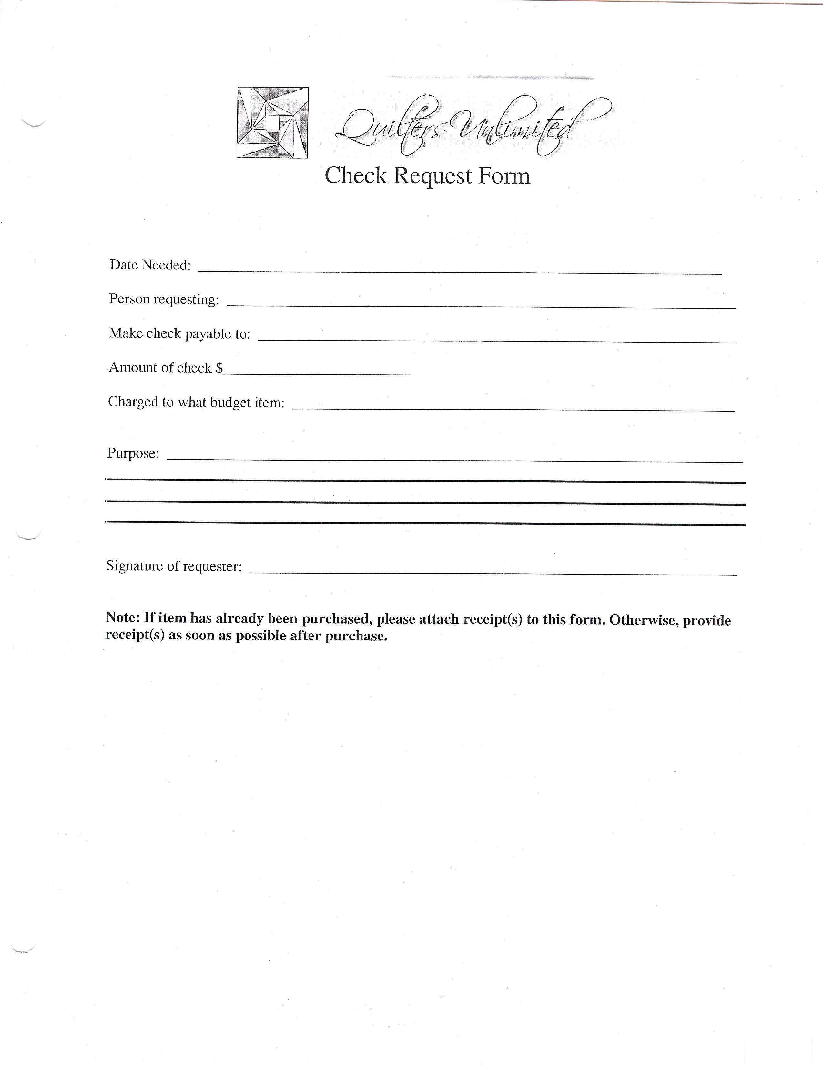

Frequently Asked Questions

- Do I have to attend every guild meeting to be the Opportunity Quilt Chairperson?
Yes, you will need to be present at the meetings to collect fabrics, disseminate kits, sell tickets, and answer member questions. If you find that a meeting conflicts with your personal schedule, simply make arrangements for someone to fill in for you. Provide ample notice, necessary materials, and detailed instructions to that individual.

- Do I have to attend the Steering Committee meetings?
It is the responsibility of either the committee chairperson or a designated substitute to attend the Steering Committee meetings. You will be familiar with the activities of the officers and the other committee chairpersons. Your input and votes are needed and your opinions will be greatly valued. You should plan to report on the progress of the quilt.

- Do I have a committee to help me with the opportunity quilt?
Most chairpersons have two to three members assist with various phases of the process. You may also want to ask five or six members to help cut the pieces for the block kits and to help assemble the kits. You may designate committee members to help sell tickets. Enlisting support of other guild members will get more guild members involved in this fund-raiser.

- What if some completed blocks are not usable because they are made too small or the seams are not even.
Unfortunately, not every block you receive may work in the quilt due to size discrepancies. Pan ahead and have extras to replace blocks that don’t fit. Guild members enjoy participating in making the quilt. An alternative to handing out kits is to have a sewing party for guild members to meet and make blocks from the kits as a group.

End of Year Report Committee: Opportunity Quilt

Complete this report in the month of October

The information that you document will be helpful to future chairpersons to know what has been done, what was successful, etc. It will also help with possible decisions about revising the role and budgetary adjustments. Use additional paper if needed. File this report on top of the previous year-end report.

Describe the year and anything unique that you did in this role:

Did you perform this role by yourself or did you enlist support from others? __________

How many other people helped you? _____________________

Explain how you needed help: _____________________________________________

_____________________________________________________________________

Budget allotted: __________________ Did you exceed your budget? ________

Where there unusual expenditures?_____ Explain:_________________________

Recommend increase in budget? _______ How much? ______________________

What obstacles did you encounter?

Helpful Hints for future chairpersons:

Recommendations for change:

Your name ______________________________ Date ______________________

