Quilters Unlimited 2018 Block of the Month: May Day Basket

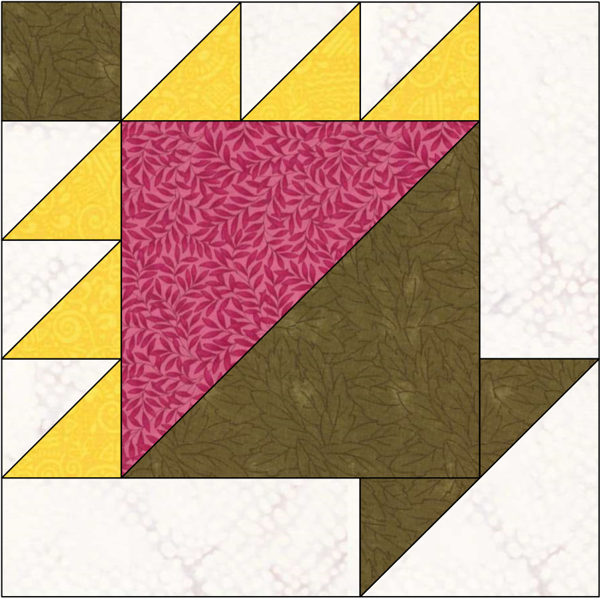

Key Block (1/5 actual size)

A

B

B

B

C

D

C

B

B

B

E

B

B

B

B

B

B

B

B

E

Cutting Diagrams Patch Count

|  |  |  |  |
| --- | --- | --- | --- |
|  |  |  |  |
| 2 | 7/8 |
|  |  |

1 patch



A

triangles

triangles

2

7/

8

B

/

1

4

3

4

1/

3



6

triangles



2



6

C

2

8

7

/

7

11/

16



2

patches

Instructions for "Basket" as 12.000 by 12.000 (inches) block, printed from EQ7!

triangle

triangle

D

5

/

5

8

8

5/

5



patch

1

E

8

1/

16

8

1/

16



1



1